Chapter 1 Lab + Homework Cheat Sheet

Starting to learn *R* is likely going to be overwhelming! First mantra: you will survive! Second: get help! You should start watching the *R* videos provided on blackboard to help get acquainted with all the ins and outs of the software/programming. You will want to watch them by the catch-up *R* lab after Labor Day.

|  |  |  |
| --- | --- | --- |
| https://youtu.be/x6Jr8ycI8ds | 1-4 | R, R Studio, and Commands |
| https://youtu.be/ZjQkg_kKg_A | 1-4 | Object Types |
| https://youtu.be/nzEiQ6injPY | 1-4 | Functions |
| https://youtu.be/-fcwWTIeiOo | 1-4 | Missing Values, Packages, and Working Directories |
| https://youtu.be/Z7hSlBpDOvs | 1-4 | Subsetting |

**Set a working directory:**

Session > set working directory > choose directory

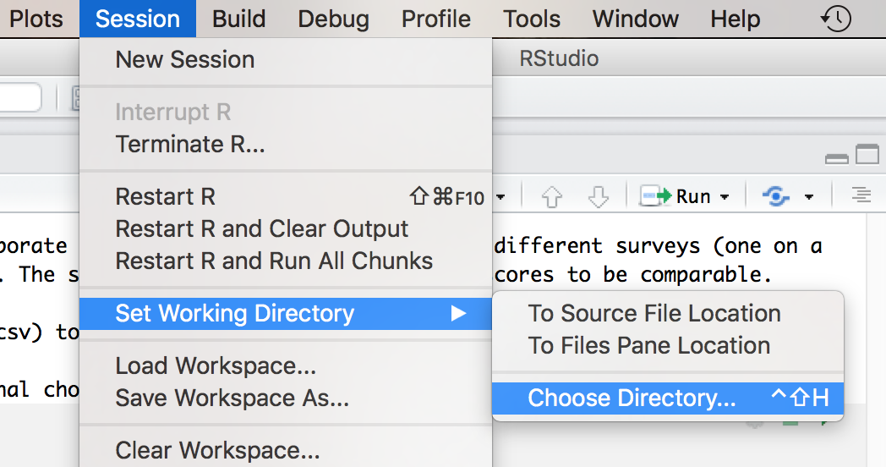

**How to load datasets:**

master = read.csv(“name of file”)

**How to create a frequency table:**

table(dataset$column)

Change the dataset to whatever the loaded dataset name is (like master from above).

Change the column to the name of the column in the dataset. Use the blue drop down arrow next to the name of the dataset in the environment window to view the column names. As you are typing you will also see the a list of dataset options after the $.

**How to create a histogram:**

hist(dataset$column)

**How to create z-scores:**

zvariable = scale(dataset$column)

**How to calculate descriptives:**

summary(dataset) ##gives you mean, median

table(dataset$column) ##gives you a frequency table to get the mode

var(dataset$column) ##variance

sd(dataset$column) ##standard deviation

**How to install a library/package:**

Click on Packages > install on the files/help window.

Type in the name of the package you wish to install.

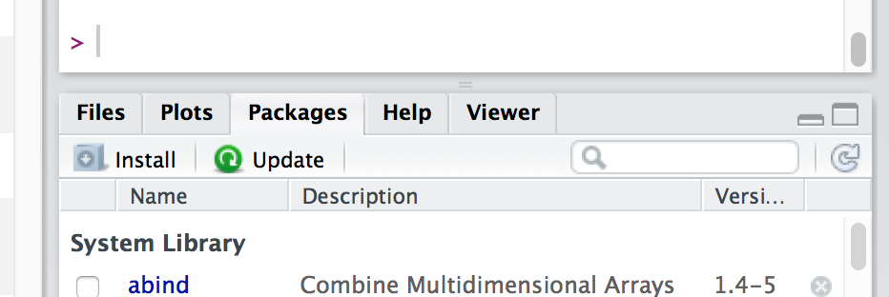

**How to load a library:**

library(packagename)

**How to calculate skew and kurtosis:**

Install the moments library. ##only necessary the first time you use it.

Load the moments library. ##always necessary

skewness(dataset$column)

kurtosis(dataset$column)